Organization of the Nervous System

Nervous System

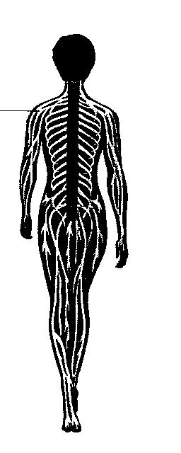
Central
Nervous
System
(CNS)
Brain, spinal cord
Peripheral
Nervous System
(PNS)

Autonomic Nervous System
(involuntary)
Relays information to internal organs.
Somatic Nervous System
(voluntary)
Relays information to and from skin and skeletal muscles.
Sympathetic Nervous System

Controls organs in times of stress
Parasympathetic Nervous
System

Controls organs when body is at rest.


Name: ___________________________________ Date: ___________________________

Organization of the Nervous System

1. What is the control center of the entire nervous system?

2. Which part of the CNS is made up of the midbrain, pons, and medulla oblongata?

3. Which part of the nervous system carries impulses between the body and the central nervous system?

4. List three kinds of neurons that would be involved in a reflex impulse.

5. Which part of the brain sends impulses to the autonomic nervous system during life-threatening emergencies?

6. Compare the parasympathetic nervous system with the sympathetic nervous system.

7. Trace the pathway of impulses through the nervous system in response to feeling rain on your skin.

